**[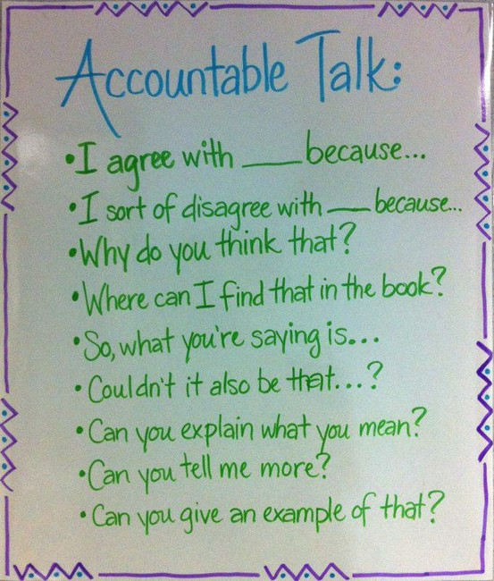](http://www.julieballew.com/A_Literate_Life/Photos/Pages/Anchor_Charts.html#55)**