Classroom Libraries

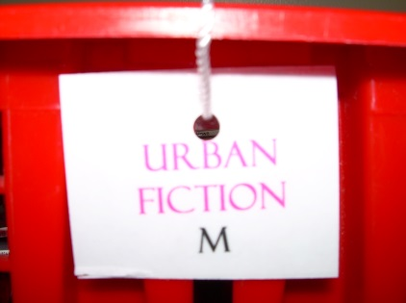
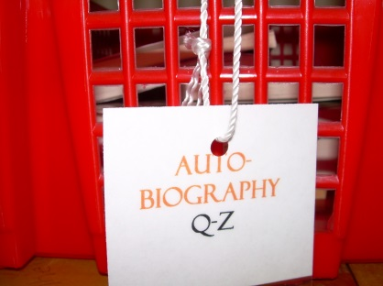

Ms. Weischaar at IS 151 has created basket labels with genre and level.

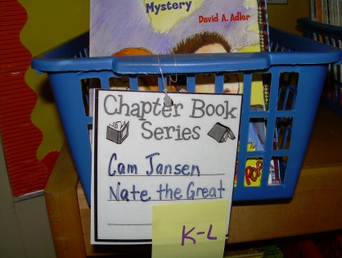
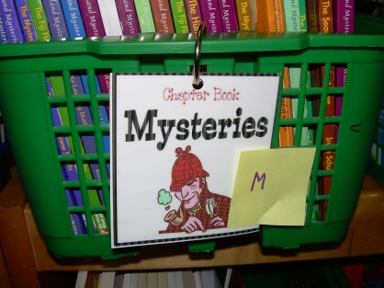

Ms. Serpico at IS 151 has created basket labels with genre and level. She has attached her labels to the baskets with key rings.

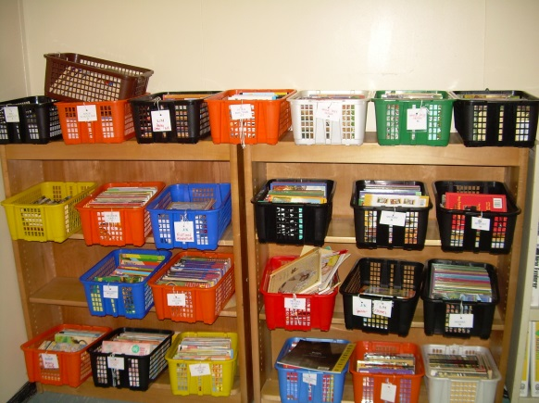
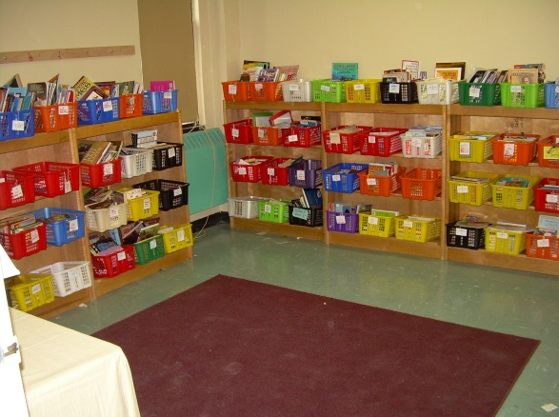

Ms. Weischaar’s library

West & North Wall East Wall

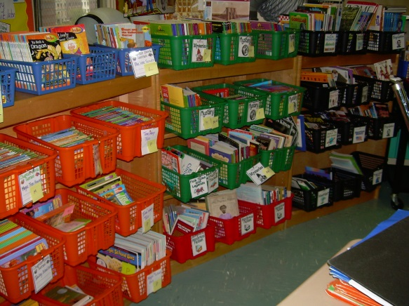
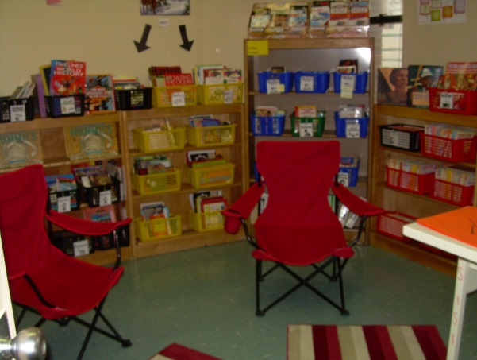
Ms. Serpico’s library
She has color coded the baskets to create sections. Mystery books are in green, series books are in blue, nonfiction is in black, etc.

Classroom Libraries
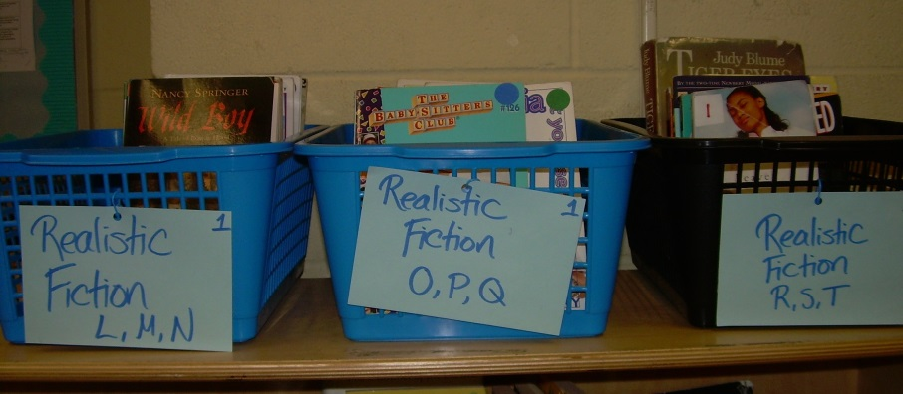
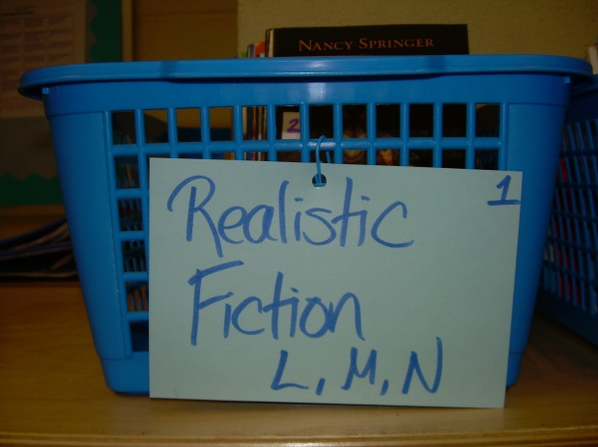

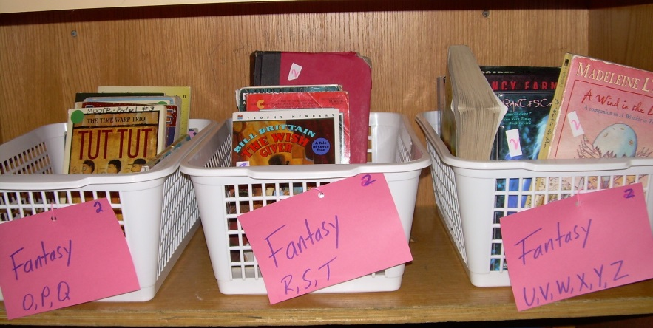

Ms. Salerno at MS 324 organized her library by genre and level. Each basket has a short range of levels. She found that doing this helped incredibly with students choosing books at their “just right” level.

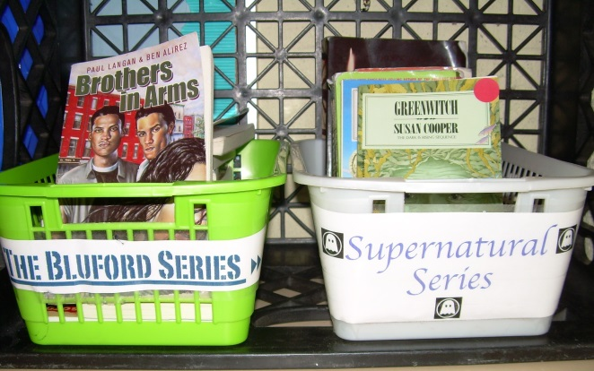
Students in Ms. Salerno’s classroom in MS 324 have created their own topic baskets. Students have created baskets of their favorite series and their favorite topics.

