Name:________________________
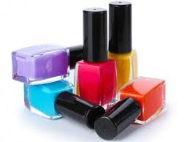
Mrs. Fischer paints her fingernails one at a time from left to right.
If she paints 1 fingernail, how many fingernails will she have unpainted?
How many other combinations of painted and unpainted nails can she have?
Remember: Read, Draw, Write!
- Read the problem.
- Draw and label.
- Write a number sentence and word sentence.

