Ideas to keep up the motivation to read during the “winter doldrum” months

An article titled “100 Creative Ways to Excite and Inspire Young Readers” that includes many website links for additional ideas/activities:
http://www.am.dodea.edu/elliott/forms/100%20creative%20ways%20to%20excite.pdf

Another article titled “Motivating Reluctant Readers,” again with other links and activities:
http://www.educationworld.com/a_curr/strategy/strategy051.shtml

A website with ideas for motivational bulletin boards, charts, reading spots, book marks, etc.:
http://www.theclassroomcreative.com/2013/08/02/ideas-for-motivating-readers/

A website with additional information about reader’s workshop
http://lauracandler.blogspot.com/2011/03/12-ways-to-motivate-reluctant-readers.html

“Increase Stamina and Engagement with Struggling Readers” (K-1) – Alison Porcelli – former staff developer; currently assistant principal at PS 59 in Manhattan
Cited Allington’s research that engagement in reading is the most powerful instructional activity for fostering growth.
She had us turn and talk about one struggling reader that we had in mind and how we’ve tried to motivate/assist that student. Then she asked “How many of you were thinking of a boy?” Every person in the room raised their hand. We have to do all we can to engage the boys in our classrooms.

Ten ways to support stamina/engagement:
Individual supports:
1. Book choice:
- May need to make books to engage students. What does he like?
- Vary up materials in the book baggies: interest books, ABC books/charts, shared reading poems, colored dot books (just right books), high frequency word ring, …
- Take a tour of the student’s book baggie and make a plan for which books he/she wants to read first.
2. Schedule (for those “List Nerds” who like to check off items when they’re done):
i.e., Adam’s Schedule
Activity Check
1. Read 2 dots books
2. Read 1 shared reading passage
3. Read 1 high interest book
4. Get a drink of water
5. Read 2 more dot books
6. Practice high frequency words on word ring

3. Tally Marks:
Put post-it notes on the back of the book and put a tally mark on the post-it note every time the book is read. Kids love points, so it keeps them motivated to “earn” them. Shows the teacher what books have been read the most, what books to focus on, what books can be used for assessment (if haven’t been read often).
4. Book stacking:
Put books in piles and then move to the other stack. This is a motivational/visual tool. “Look at all the work I’m accomplishing!”

5. Goal setting:
Set a concrete goal – either number of books or amount of time reading
Write the number of books on a post-it and then get a little break/incentive after accomplished (i.e., high five, little dance, etc.)
Set a visual-release timer and then allow a break after so many minutes. (May have to create a break menu.) Then see if student can beat his/her time.
6. Re-reading menu:
Give students purposes to re-read books:
Re-reading Menu (check)
1. Make it smooth
2. Storyteller (voice like a teacher; hold the book like a teacher)
3. Act it out (use body motions)
4. Notice New Things
5. Sing (Put a tune to it) – Levels A - E

She had this re-reading menu on a large post-it from Target (not Staples; it’s cheaper). Put it on the back of the book(s).

7. Partner-reading:
Students who aren’t engaged can read with a partner the whole independent reading time. Pair 2 struggling readers who are friends and reading at the same level.

Partner “Games”
- Be the Teacher – one student knows the book well. He/she holds up one of two cards while the other student reads – “Oops! Fix it up!” or “Good Job! Keep Going!” at the end of every page.
- Echo – one student reads and points; then the other echoes.
- Shared Reading – read with a pointer like a teacher
- Tricky Tricky Teacher – take a post-it and cover up a word with a sticky; have partner guess
- On Stage – act book out
- American Idol – sing it
- What’s Next – say that at the end of every page and make a prediction
May have these games written out in a folder and can move them from one side of the folder to the other as complete them. Kathy Collins says to do partner time first to motivate and then do independent reading time.

Whole-class supports:
8. Design a unit of study on reading engagement/motivation and have a Rally Cry:
“We’re going to work on our reading strategies and moving up reading levels!”
“Olympic Readers in Training”
9. Stamina Chart: How was ____ Stamina Today?
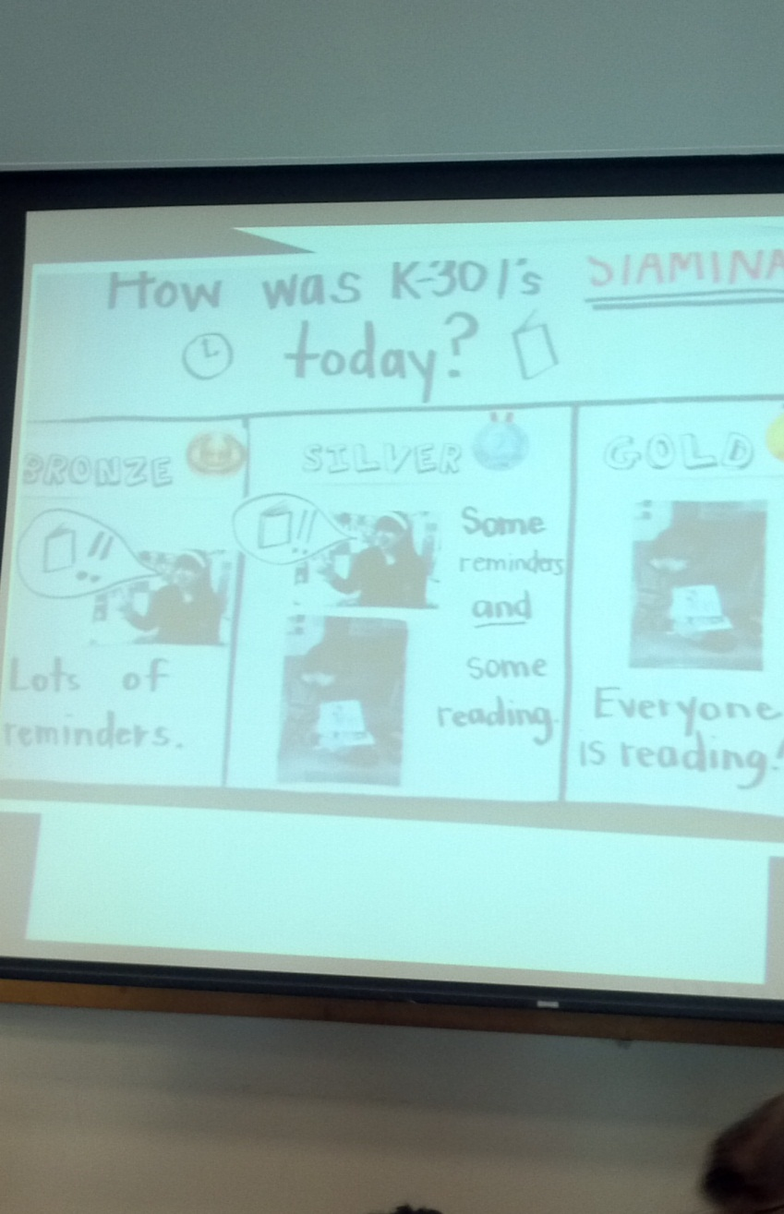

10. Class Goals/Reflection:
Set a stamina goal each day – read more books as a class, read for a certain number of minutes as a class, use more reading strategies as a class, …

