Section F:
Cultural Competence and Equity

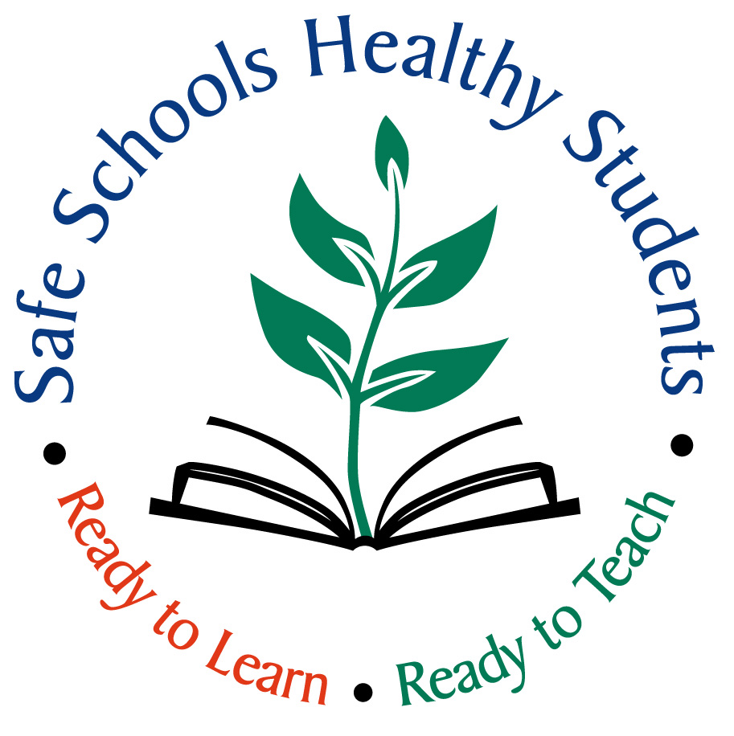

Section Contents

Introduction to Cultural Competence page 96

Focus Areas
Data and Disproportionality page 98
Differences in Power page 100
Developing a Culturally Respectful Environment page 101



Tools
Recognizing the Educational Impact of
Cultural Diversity page 106
Addressing Demographic Inequities in
Achievement page 107
Building Relationships across Cultural Differences page 108
Adapting Curriculum to Reflect Cultural Diversity page 109
Ongoing Self-Reflection about
Cultural Competence page 110
Administrator Cultural Competence
Self-Assessment page 111
Staff Cultural Competence Self-Assessment page 112
Student Survey page 115
Classroom Observation Form page 116
Parent Survey page 118
Strategies for Discussion Differences page 119
Guidelines for Study/Action Groups/PLCs page 120
Sample Questions to Begin Discussions
about Culture page 121
Classroom Activities for Learning About
Students’ Culture page 122
Resources page 123

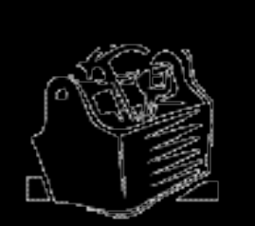

Introduction: Cultural Competence and Equity

MPS has an increasingly diverse student population attending our schools. Yet, persistent disparities in achievement exist between students of color and their white counterparts. District data clearly indicate that we are not successful with all children.

While the concepts in this section relate to the wide variety of “isms” that students experience, this section will primarily address the impact of culture, race, and racism on student success. (For more information, MPS English Language Learners at: http://ell.mpls.k12.mn.us/.)

There are several definitions of cultural competence in research. Although definitions vary, at the core is: The ability to function comfortably in cross-cultural settings and to interact harmoniously with people from cultures and races that differ from your own.

Cultural competence is informed by an understanding of the role of race and racism in our society and in our schools. By definition, racism connotes that certain groups have power, and others do not. One of Glenn Singleton’s six conditions necessary to begin courageous conversations is a focus on race. We often focus on the impact of culture and socioeconomic status as barriers to student success. Data indicate that even when one controls for socioeconomic status, race emerges as a more critical factor in student achievement; even in the highest socioeconomic groups, white students continue to outperform students of color.

Shifting the climate of a school building to address race and culture openly, especially given the impacts of institutional racism is a daunting job. A starting place:

- Develop an awareness of one’s beliefs and values toward people of races and cultures different than your own and how those beliefs and values contribute toward actions that have a negative impact on communication, relationship building and desired outcomes.
- Develop an acceptance of, followed by a desire to obtain knowledge about, specific groups, the socio-political history of the U.S. as it relates to oppression of various ethnic and racial groups, and the politics of education that take a monocultural position toward education in a pluralistic school community
- Acquire verbal and non-verbal skills to more effectively reach the diverse students represented in our classrooms.

Effective cross-cultural relationships aren’t dependent on the teacher knowing everything about the cultural practices of all their students. However, culturally competent teachers acknowledge their ongoing need to learn, and keep open lines of communication with students and families.

Culturally competent individuals:
- Value diversity
- Engage in self-reflection
- Manage the dynamics of difference
- Adapt to the cultural contexts of the students and communities they serve
The table below forecasts the focus areas and tools in this section, and offers some practical tips for building leaders to implement in their schools.

Sources: Courageous Conversations about Race, Singleton and Linton, 2006; and Hopkins School District 270 Framework for Effective Teaching, 2003. Counseling the Culturally Different: Theory and Practice, 4th edition. New York: John Wiley. Adapted from Sue, D.W., & Sue D (2003).

Focus Areas | Role of Building Leader(s)
Disproportionality and Data Use | - Examine data to identify areas of disproportionality.  - Identify resources and supports from the community that can help support students whose data is disproportionate.  - Work with staff to develop questions that are always used when looking at data.  - Establish a set of criteria that will be the core for selecting practices – fit with need, based in experience with similar school populations, skill requirements, etc.  - Establish a library of research-based practices for staff to use as they make decisions.
Differences in Power | - Talk with staff about differences in power and invite them to talk with each other.  - Model behavior that balances power.  - Observe students in the building and watch for examples of power differences.  - Talk with students about power differences and help them identify ways to interact to balance power.
Developing a Culturally Respectful Environment | - Pay attention to your own tendencies when you are in conversation: Are you defensive? Wanting to explain before a question is asked? Listening carefully and openly without preparing your own response?  - Teach staff and students about dialogue and give opportunities to practice with each other and get feedback.  - Become a champion of positive school climate.  - Engage others who are interested in being co-leaders in specific efforts.  - Examine own beliefs about disproportionality and learn to model cultural competence. Share whatever struggles you are having with your staff; let them see how you deal with these difficult issues.  - Conduct an environmental scan and identify areas where steps can be taken to make building more respectful of other cultures.


Focus Area: Data and Disproportionality

“ Cultural and racial issues need to be acknowledged and addressed; disproportionality is an issue.”

While many of us have been taught not to see color or differences and to treat everyone the same, differences exist. When we begin to really see students, we see differences in race, culture, physical ability, sexual orientation, and learning styles.

Disaggregating the data reveals that some subgroups of students appear disproportionately higher in some areas and lower in others than would be expected, given the percentage of the students in the general population. African American males, for example, are suspended from school at a higher rate than any other student subgroup. The percentage of Native American students who graduate from high school in four years is lower than the percentage of white students. These educational inequities (an overrepresentation of students in some data categories and an under-representation of students in others) are collectively known as disproportionality.

Using Data to Assess School Climate (Section A) offers suggestions about effectively using data. Data on student progress, gathered and used regularly, is an empowering tool for teachers who are committed to teaching all students; it provides essential information for designing and differentiating classroom instruction. Further, disaggregating student achievement data by demographic groups provides an opportunity for teachers to reflect on instructional practices as well as institutional policies, practices and programs that may unintentionally perpetuate patterns of under achievement among certain groups of students.

Each school has to do the work of identifying the disproportionality that exists within its own data.

Using Data to Address Educational Inequities
Choose a given criteria, and ask yourself a series of questions: | Some deeper questions are:
How do students of color perform, compared to white students?  How do male and/or female students of color perform, compared to the same group of white students?  How do special education students perform, compared to those in general education?  How do English language learners compare to other students? | What implications does the data have for instruction?  What additional or different instructional strategies do teachers need?

Using Data to Address Educational Inequities
Beyond academic assessments, behavioral data enriches the analysis: | The next level of understanding:
How do suspensions look by racial, ethnic and linguistic groups?  How does your attendance data look by group? | What are the specific offenses for which students are being suspended? Are they the mandated reasons or are students being suspended for other reasons as well? Does that answer change, depending on the group you are looking at?  Which teachers are referring the greatest numbers of students? Are those numbers proportional to what you would expect, given the general population of the school?  What time of day are the greatest numbers of referrals happening?  What percentage of referrals results in suspensions? What is this answer for the different groups of students?

Identifying Research-Based Practices
Once building leaders and staff have a clear picture of their needs from analysis of the data, you can develop an action plan. What training does staff need to become culturally competent? What have other schools done to address behavioral issues? What specific strategies have they used that impact students from different racial groups? This is the point to identify strategies to address the gaps that have emerged.

In making decisions about programs and instructional materials, look for the closest match to the needs of students:

- Does it address the specific challenge you have defined?
- Is there research that supports the statements about the program’s effectiveness? Has it been conducted in schools with similar ethnic/racial/linguistic/socioeconomic characteristics?
- Is it age-appropriate for your students?
- Do your teachers have the skills necessary to implement it? If not, how much training do they need and is that provided?
- Where has it been successful before? Do those schools match yours in demographics? Ages of students? Types of other challenges?
- Is this an approach that your teachers can take ownership for? Do they support its use?

Focus Area: Differences in Power

“I watch groups of students interact with each other and with the staff, and it’s like they just don’t hear each other. Everyone discounts everyone else, and the climate just continues to go downhill fast.”

At its heart, cultural competence is about power. It is important to recognize the power inherent in positions, such a principal and classroom teacher. Equally important is using that power to help all students succeed.

Within the context of cultural competence, power is defined as the ability to make things happen.

Teachers lectured in traditional classrooms and held all the power. They generated the talk, dispensed the knowledge, gave grades, and handed down the discipline. In more recent times, instruction has become more engaging, distributing the power among the students and the teacher. It is important to note that sharing power in instruction does not mean that the teacher is abdicating authority or responsibility.

Think for a moment about the discipline disruptions that often happen in classrooms. One scenario is the young person who is not academically successful and becomes a class clown when forced to sit still through a lecture or lesson. Put in terms of power, the student’s power to influence has been stripped away by being put in a situation where he has no influence. So, he influences in the environment in any way he can. Other children, who perhaps are not successful, but who are not acting out, are often exercising their power by withdrawing from the scene emotionally and mentally.

When confronted by differences that we don’t understand—like cultural differences—we interpret that as a loss of power. We are no longer able to understand or influence this other person in the same ways our own culture has taught us to. So we revert to relying on stereotypes and preconceived perceptions that “fit” our cultural expectations.

Cultural competence is “the ability to function comfortably in cross-cultural settings and to interact harmoniously with people from cultures that differ from your own.” When we are able to balance the power in the relationship, we will be able to function comfortably and interact harmoniously with people from cultures that are different from our own.

Focus Area: Developing a Culturally Respectful Environment

One way you can begin to support individuals in changing their behavior is by changing their environment. The first move a leader can make is to change your own behavior. The next steps occur when you begin to model cultural competence in the decisions you make, the questions you ask, the expectations you articulate, and the environmental changes you facilitate.

Leadership in Cultural Competence
Leaders must be the champions of a positive school climate. People must see leaders model positive interactions, use data, and be consistent in behaviors. Staff needs to hear them talk about the benefits of a positive school climate and address issues of race, culture and other “isms”. Staff must receive support and challenges. The principal has to balance the power with them first. Listen and speak with them as though you were in dialogue, even when the other person is talking “at” you or “to” you. Allow each person with whom you come in contact to influence you with the power of who they are, rather than the power of what they are saying or doing.

The National Commission on Teaching and America’s Future (1996) cites teacher quality⎯content knowledge and effective strategies ⎯as a significant factor in student achievement, particularly for students of color. Closing the achievement gap requires highly qualified teachers, culturally responsive instructional strategies, and continuous examination of the institutional conditions that perpetuate achievement inequities. In every building, leadership must articulate these concepts and support staff in achieving this level of rigor.

As a leader addressing these issues in your building, some strategies include:
- Develop a plan.
- Identify individuals who show interest in making this shift.
- Talk with them about becoming champions of these efforts.
- Agree to share feedback with each other about the progress you are making individually.
- Engage them in learning more about these issues.
- Continue to grow that circle of champions as you engage others.

Staff Ratios
Students need to see themselves as successful learners. Having a diverse staff helps students to see that all kinds of people can be successful learners. In today’s market place, it may not be easy to find staff who match the diversity among your students, but you can make every effort to make that happen.

Possible Strategies
- Look for and hire skilled staff with a variety of backgrounds from different racial and ethnic groups.
- When you cannot hire staff to meet that goal, arrange for community volunteers to come into your school and classrooms to teach specific lessons, engage them as volunteer tutors or mentors, etc. Have them work as model learners in your building so that students can begin to see people like themselves in positions of learning and authority.

Curriculum
Students need an academically challenging curriculum that includes the contributions and perspectives of the different racial, ethnic and cultural groups. Learning should reflect the diversity in a school.

Possible Strategies
- Where textbooks and materials fall short of providing a diverse picture of the world, have staff supplement with other images and materials. Model skills to embed a variety of authentic multicultural resources into the core curriculum.
- As an instructional leader, support staff in preparing instructional materials that provide for more equitable learning opportunities, and use literature, music and other resources from diverse cultures to provide “windows and mirrors” for students.
- Help all staff create a welcoming classroom environment that physically reflects the diverse cultures, interests and experiences of students
- Encourage teachers to talk with students about differences and help them to be comfortable with them.
- Help teachers embed multicultural content and multiple perspectives into the core curriculum and engage students in reflecting on their personal racial/cultural experience/background in relation to the curriculum.

Instructional Strategies
Current research suggests that the most effective educational approaches draw upon the knowledge and skills that students bring to the classroom. Using this knowledge helps to build high student achievement through demanding, interesting, and culturally relevant experiences. Help staff learn to incorporate knowledge of students’ cultures into the design of content and strategies. Make sure teachers know and use strategies that meet the needs of all children in their classrooms, and support them in seeking new and different strategies as your student population continues to change. Support staff in finding instructional approaches that honor the differences among your students.

Possible strategies
- Help staff recognize the educational impact of culture and use instructional strategies that build on students’ cultural strengths and promote success
- Promote staff dialogue about how to recognize and intervene on their own and other’s predisposed expectations about student ability/performance
- Support staff to dialogue with each other about ways to engage students in reflecting on their cultural backgrounds and share information, traditions, etc.
- Help teachers use cultural knowledge and achievement data to design and deliver differentiated learning opportunities for students.

Environmental Scanning
Instructional materials and strategies are not the only ways in which your students receive messages about your preferences. The curriculum, along with the physical classroom and school environment, should function both as a window and a mirror in order to reflect and reveal most accurately our diverse, multicultural world and the student herself or himself.

Possible Strategies
- Examine the environment of your building and involve all staff in creating a more inclusive climate.
- Create signage in your building so that if most of your families and caregivers are non-English speaking, there is signage in their native languages. Not only will their children look around and see their “roots” being honored, but also when the families and caregivers come to the school, they will feel more welcomed.
- Examine posted student work, messages of welcome, office décor and other visual attributes of your school to assure that they are welcoming to diverse students, staff, and visitors.
- Help teachers to actively engage students in designing the classroom environment to reflect their students’ personal cultural experiences and backgrounds.
- Institutionalize professional learning communities and/or discussions about instruction in light of differences in race and culture

Personal Reflection
Culturally competent leaders and staff recognize the relationships between culture and learning, they continually reflect upon their own cultural experience and the experience of their students, and they consistently use this knowledge to create learning environments that students’ diverse learning needs. To understand the impact of culture as it relates to self is the beginning of understanding and acceptance of others whose culture may be different.

- Reflect on culture, your personal cultural experience, and how your own experience shapes your assumptions and expectations about students in your building.
- Pay attention to your own tendencies when you are in conversation. Are you defensive? Wanting to explain before a question is asked? Listening carefully and openly without preparing your own response?
- Examine your own beliefs about power and disproportionality and learn to model cultural competence. Share whatever struggles you are having with your staff; let them see how you deal with difficult issues.
- Teach staff and students about dialogue and give opportunities to practice with each other and give feedback.

Use of Dialogue
Dialogue is talking without defending and listening without judging. It is saying what you want to convey and hearing what the other person is saying. When in a dialogue, you have to speak the truth in ways that the other person can hear. Criticism, sarcasm, boasting, jargon, and positional statements all have a negative effect. Singleton suggests four agreements to be used when in dialogue:

- Stay engaged
- Experience discomfort
- Speak your truth
- Expect/accept non-closure

It means being open to the message of the other person, and when appropriate, articulating your dislike for or discomfort with what they are saying and how they say it. You have the right to state your position about how they might be expressing themselves, but you have to do so without blame, shame, or accusations.

Tool Guide: Cultural Competence and Equity
 Recognizing the Educational Impact of Cultural Diversity page 106
 Addressing Demographic Inequities in Achievement page 107
 Building Relationships across Cultural Differences page 108
 Adapting Curriculum to Reflect Cultural Diversity page 109
 Ongoing Self-Reflection about Cultural Competence page 110
 Administrator Cultural Competence Self-Assessment page 111
 Staff Cultural Competence Self-Assessment page 112
 Student Survey page 115
 Classroom Observation Form page 116
 Parent Survey page 118
 Strategies for Discussing Differences page 119
 Guidelines for Study/Action Groups/PLCs page 120
 Sample Questions to Begin Discussions about Culture page 121
 Classroom Activities for Learning about Students’ Culture page 122
 Resources page 123
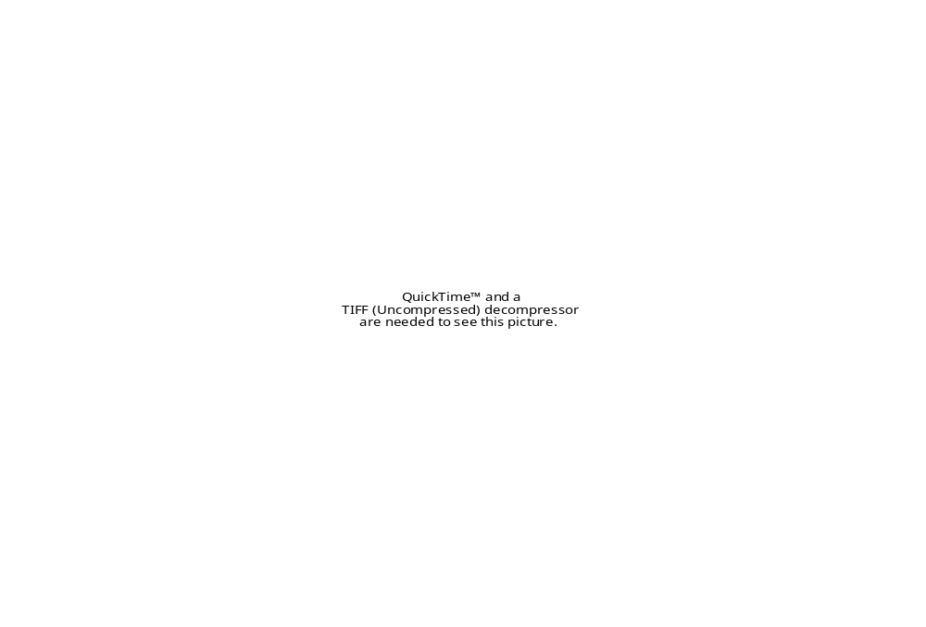
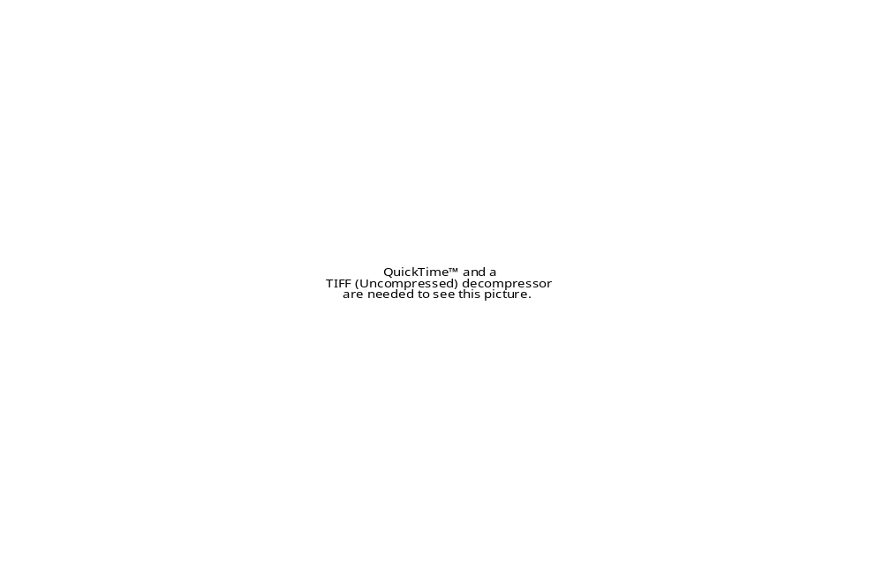



Tool: Administrator Cultural Competence Self-Assessment

This assessment will allow you to examine your own cultural competence and help you identify areas of personal and professional growth. School leaders set the tone and the direction of a school. It is crucial that administrators understand their own attitudes and bias regarding cultural competence and racism before assisting staff in examining this issue and implementing changes in schools.

Reflect on the following questions to determine where you are on this subject. Cultural competence is a process. Conduct this self-assessment at least two times during a school year to determine and heighten understanding and growth.

- What are some of my beliefs or assumptions about students of color in general?

- What are some of my beliefs or assumptions about the ability of students of color to learn different behavior if behavior is a problem?

- What are some of my beliefs about families of color in general and specifically, their interest in their children’s education?

- What is my belief about the ability of students of color to learn challenging academic work?

- How would I handle my staff’s resistance to discussing issues of race or culture?

- How would I handle my staff’s resistance to implementing cultural changes in our building, classroom, curriculum or instruction strategies?

- What would be my resistance to discussing issues of race or culture in my building?

- What would be my resistance to implementing cultural changes in our building, classroom, curriculum or instructional strategies?

- If I had fears related to this topic, what would they be?

- What do I believe is the major reason(s) why a high percentage of students of color do not excel academically?

Tool: Staff Cultural Competence
Self-Assessment

Use this assessment with staff after you have begun discussions about this issue. Reassure them that this is a process to create feedback to identify ways to help them grow.

Directions: Please write 3, 2, or 1 in the space before each of the following statements.

3 = I do this frequently
2 = I do this occasionally
1 = I do this rarely or never

Physical Environment, Materials, and Resources
_____I display pictures, posters, artwork and other décor that reflect the cultures and ethnic backgrounds of students and families served by our school.
_____I ensure that magazines, brochures, and other printed materials reflect the different cultures of students and families served by our school.
_____When using videos, films or other media resources, I ensure that they reflect the cultures and ethnic background of students and families served by our school.
_____I ensure directly or indirectly (by reminding administration or other staff) that information sent home takes into account the average literacy levels and language of the students and families served by our school.

_____subtotal/4 = _____average

Communication
When interacting with students and families who have limited English proficiency I keep in mind that:
_____Limitation in English proficiency is in no way a reflection of their level of intellectual functioning.
_____Their limited ability to speak the language or to express themselves in the same way as the dominant culture has no bearing on their ability to communicate effectively.
_____They may or may not be literate in their language of origin or English.
_____I use bilingual-bicultural staff and/or personnel to interpret during meetings and other occasions for students and families who need or prefer this level of assistance.
_____I attempt to understand any familial colloquialisms used by my students and families that may impact our communication.
_____For students and families who speak languages or dialects other than English, I attempt to learn and use key words in their language so that I am better able to communicate with them.
_____I understand that it may be necessary to use alternatives to written communications for some students and families, as direct communication via phone or through another person or organization they are familiar with may be more effective and preferred.

_____subtotal/7 = _____average

Values and Attitudes
_____I avoid imposing values that may conflict or be inconsistent with those of cultures or ethnic groups other than my own.
_____I screen books, movies, and other media resources for negative cultural, ethnic, or racial stereotypes before using them in curriculum and instruction or sharing them with students and families served by our school.
_____I intervene in an appropriate manner when I observe students or other staff engaging in behaviors that show cultural insensitivity, racial bias and prejudice.
_____I recognize and accept that individuals from culturally diverse backgrounds may desire varying degrees of acculturation into the dominant culture.
_____I understand and accept that family is defined differently by different cultures (e.g. extended family members, fictive kin, godparents).
_____I accept and respect that male-female roles may vary significantly among different cultures and ethnic groups (e.g. who makes major decisions for the family).
_____I understand that age and life cycle factors must be considered in interactions with individuals and families (e.g. high value place on the decision of elders, the role of eldest male or female in families, or roles and expectation of children within the family).
_____Even though my professional or moral viewpoints may differ, I accept the parent/guardian and families as the ultimate decision makers for educational services and, supports needed for their child.
_____I recognize that the value of education may vary greatly among cultures.
_____I understand that religion and other beliefs may influence how students and individuals respond to traditional education.
_____I understand that the perception of education has different meanings to different cultural or ethnic groups.
_____I seek information from students, families or key community resources that will assist in curriculum/instruction adaptation to respond to the needs and preferences of culturally and ethnically diverse groups served by our school.
_____Before making a home visit, I seek information on acceptable behaviors, courtesies, customs, and expectations that are unique to the culturally and ethnically diverse groups served in our school.
_____I keep abreast of the major educational concerns and issues for the ethnically and racially diverse student/family population served by our school.
_____I am aware of the socio-economic and environmental factors that can contribute to educational problems for the culturally, ethnically and racially diverse populations served by our school.
_____I do not use knowledge of these factors to lower my level of expectations for my students regarding their behavior or academic performance; rather, I provide additional support as needed.
_____I avail myself to professional development and training to enhance my knowledge and skills in the provision of services and supports to culturally, ethnically, racially and linguistically diverse students.
_____I strive to become competent in the most current and proven best practices for educating culturally, ethnically, racially and linguistically diverse students.
_____I advocate for the review of my school’s mission and vision, goals, policies, practices, and procedures to ensure that they incorporate and reflect principles and practices that promote cultural and linguistic competence.

_____subtotal/19 = _____average

How to Interpret Your Results
This checklist/assessment tool is intended to heighten awareness and sensitivity to the importance of cultural and linguistic cultural competence. It provides concrete examples of the kinds of beliefs, attitudes, values, and practices that foster cultural and linguistic competence. There is not an answer key with correct responses. However, if you frequently responded “1” you may not necessarily demonstrate beliefs, attitudes, values and practices that promote cultural and linguistic competence within an educational setting.

Source: Adapted from Material Developed by the National Center for Cultural Competence, Georgetown University Center for Child and Human Development, Washington, D.C. April 2004.
Tool: Student Survey
Use this survey to collect data about how students experience diversity in school. Do not write name on sheet.

Ethnicity or race________________ Grade level _______ Date____________

1. I feel accepted and a part of my school. Yes____ No____ A little____

2. I feel that students of my race or culture are respected and treated fairly in my school.
Yes____ No____ Sometimes____ Not sure____

3. My teachers and other school staff make me feel accepted and a part of my school by:
Smiling at me____ Asking me in a kind voice to do things____
Not yelling____ Saying “good morning”____ Helping me ____
All of the above____ None of the above____

4. My teachers seem comfortable talking to and teaching students from my race and culture.
Agree____ Some do ____ Disagree____

5. My teachers make it clear what I am supposed to learn.
All of them do____ Some do____ None of them do____

6. My teachers provide help when I do not understand the material.
All of them do____ Some do____ None of them do____

7. My teachers expect all students in their classes to succeed, no matter who the students are.
All of them do____ Some do____ None of them do____

8. When it comes to discipline, my teachers treat all students fairly.
All of them do____ Some do____ None of them do____

9. There are pictures, videos, or assignments in my class/school that relate to my culture or race.
True____ Not true____

10. I would like more pictures, videos, or assignments that relate to my culture or race.
Yes____ No____ Not sure____

11. Teachers and staff at my school intervene when they see or hear name-calling, pushing or other things related to race or culture.
Yes____ No____ Not sure____

12. Teachers and other school staff provide help for students who cannot speak English well.
Agree____ Disagree____ Not sure____

Use this as a part of your environmental scanning to collect data about diversity around the building. It can also be used by the individual teacher/mentor team to provide feedback on an ongoing basis.
Tool: Classroom Observation Form

Teacher:
Classroom:
Date: Time:
Observer:
 |  | Degree of Implementation
 |  | Low |  | High
Classroom expectations and rules were posted. | Not observed | 1 | 2 | 3 | 4
Expectations and rules were enforced in a positive manner. | Not observed | 1 | 2 | 3 | 4
Teacher monitored student compliance with rules. | Not observed | 1 | 2 | 3 | 4
Teacher have reminders about expected behavior in advance of activity. | Not observed | 1 | 2 | 3 | 4
Teacher used inappropriate behavior as an opportunity to re-teach or reinforce behavior expectations. | Not observed | 1 | 2 | 3 | 4
Teacher praised students often when they were appropriate, using specific examples about what s/he liked. | Not observed | 1 | 2 | 3 | 4
Students appeared to understand the rules and routines, and understand the consequences for misbehavior. | Not observed | 1 | 2 | 3 | 4
Teacher handled behavior disruptions consistently and promptly. | Not observed | 1 | 2 | 3 | 4
Teacher used behavior management techniques (contracting, reinforcement systems) with individual students. | Not observed | 1 | 2 | 3 | 4
Teacher exhibited high expectations for behavior for all students despite their culture or ethnicity and providing additional support as needed. | Not observed | 1 | 2 | 3 | 4
I observed teacher exhibiting high expectations for the academic performance of all students despite their culture or ethnicity and providing additional support as needed | Not observed | 1 | 2 | 3 | 4

Physical Environment, Materials & Resources
Pictures, posters, artwork and/or décor that reflect and respect the cultures and ethnic groups of students and families served by this school were on display. | Not observed | 1 | 2 | 3 | 4
Video, films and other media resources reflect and respected the cultures and ethnic groups of students and families served by this school. | Not observed | 1 | 2 | 3 | 4

Communication
Teacher communicated with students in a respectful manner. | Not observed | 1 | 2 | 3 | 4
Teacher was patient with students with limited ability to speak English or express themselves in a clear and concise manner. | Not observed | 1 | 2 | 3 | 4

Values and Attitudes
Teacher did not impose values that may conflict or be inconsistent with the student’s culture or ethnicity. | Not observed | 1 | 2 | 3 | 4
Teacher screened curriculum material for negative cultural, ethnic, or racial stereotypes before using it. | Not observed | 1 | 2 | 3 | 4
Teacher intervened in an appropriate manner when observing students engaging in behaviors showing cultural insensitivity, racial bias and prejudice. | Not observed | 1 | 2 | 3 | 4
Teacher displayed a level of competence in best practices for educating culturally, ethnically, racially and linguistically diverse students. | Not observed | 1 | 2 | 3 | 4

Those areas not applicable or relevant are not marked.

Comments:

Source: Closing the Achievement Gap: What Doesn’t Meet the Eye, Learning Point Associates; National Center for Cultural Competence, April 2004

Tool to assess a school’s level of cultural competence. May be presented at a parent meeting, family activity night or distributed at school’s front desk. It may be helpful to use this survey in conjunction with a parent focus group; see page 23 for details about conducting a focus group.
Tool: Parent Survey
The purpose of this survey is for our school to find out how all of our parents from all cultures feel about our school. Please circle “yes” or “no.”

Your Ethnicity or Race_________________ Child’s grade level_____________

My child’s school is a warm and friendly. Yes No
Teachers at this school care about my child. Yes No
Teachers are fair in how they discipline students. Yes No
I am pleased with the quality of work assigned to my child. Yes No
Teachers respond well to my concerns. Yes No
The principal responds well to my concerns. Yes No
The school staff makes it easy to get more involved in the school. Yes No
This school is sensitive to the needs of all cultures. Yes No
This school displays posters, artwork and other décor that reflect all cultures. Yes No

When sending material home, school staff considers the different languages Yes No
and reading levels of families served by the school.

Teachers at this school have high expectations for my child. Yes No

Teachers provide my child the support they need to be successful. Yes No

School staff responds quickly and appropriately to issues of racism Yes No
observed or reported by my child.
Tool: Strategies for Discussing Differences

This tip sheet has useful suggestions for opening the conversation at your building.

- Administrators should attend a workshop or conference on the topic, followed by a self-assessment of beliefs and attitudes (sample self-assessment form included in this section).
- Establish and maintain issues of culture, equity and disproportionality as a high priority.
- Collect data to illustrate the problems around these issues (e.g. achievement gap, referrals, suspensions).
- Introduce topic to all staff. Bring in outside facilitator if needed. Begin discussions. Use an open/non-blaming process. Establish a collegial approach.
- Acknowledge that:
  - Race and culture are often difficult to talk about.
  - Many of us have had experiences with conversations about race where the outcome was not positive.
  - Having discussions about race and differences involves taking a risk.
  - What is comfortable for us personally may not be comfortable for others.
  - If the outcome can lead to improved relationships and improved performance for all of our students, then the discomfort would be worth it.
- Have all staff complete a cultural competence pre self-assessment. Conduct a post self-assessment near the end of the school year to determine change/growth. Results should be tabulated and discussed as a team. Anonymity should be maintained.
- Develop PLC or study group to discuss topics related to these issues on a monthly or semi-monthly basis. Can include all staff, an existing committee or newly formed committee. If small committee format is used, all school teams, administration and specific disciplines (e.g. social worker, counselor, psychologist) should be represented.
- Develop plan for heightening awareness of topic, assessing issue school-wide, in classrooms, gathering student and parent perspective and implementing changes.
- Focus on best practices for classroom instruction, student/teacher relationships, etc. Assess whether there are differences in how best practices are implemented depending on the culture of the student.
- Help staff understand the difference between being colorblind and seeing students as individuals.
- Help teachers build their sense of efficacy with all students, and normalize the learning of new strategies.
- Maintain high standards and accept no excuses, from yourself or others.

An effective approach for helping people to understand cultural competence is to engage them in ongoing learning and dialogue about the issues. Use this Tip Sheet to start some of those conversations.
Tool: Guidelines for Study/Action Groups/PLCs

- Schedule appropriate space and time for meeting.
- Create meeting agenda.
- Begin meetings by listening and responding to group reports.
- Before each meeting, decide whether it would be more effective to have groups read article ahead of time or during meeting. Keep in mind length of article, subject matter and how much time you think groups will need to accomplish tasks.

Issue:

Article:

1. Have staff form team groups and read article if it wasn’t read ahead of time.

2. Have teams share/reflect:
- What did you learn from article?
- How does this issue impact you and your position?
- How does this issue impact the students with whom you work?
- Will your awareness of this issue help you become more effective? Why or why not?
(Facilitator can add as many questions as s/he deems pertinent to issue.)

- Instruct teams to brainstorm and create one or two strategies they can immediately implement in classrooms/school and be ready to report at next meeting. (This can be done in same setting or teams can use other time to complete task.)

- Begin next meeting with teams reporting new strategies to staff (see Team Report Form).

Sample Issues
- White privilege
- Social capital
- Standard English and African-American English
- Does culture or race matter in the classroom?
- Culturally responsive teaching
- Multicultural education

Tool: Sample Questions to Begin Discussions about Culture

- How long have you lived in Minnesota? What brought you here?

- We all come from different cultures. What do you like most about your own culture? What are some of the strengths of your culture?

- What are some ways that your culture shows respect for others?

- How does your culture relate to issues of time? Authority? Individualism vs. collectivism? Equity/fairness?

- Share an experience when you were offended, hurt or disrespected because of your race or culture.

- How do people from your culture approach conflict?

- On a scale of 1–5, with one being low, how comfortable are you with discussing issues of race and culture. What would help you be more comfortable?

Tool: Classroom Activities for Learning about Students’ Culture

This sheet provides suggestions for teachers to use in their classrooms to help them engage students around cultural issues.

Questions for Discussion
- What holidays does your family celebrate?
- What other events or occasions does your family celebrate or observe?
- What foods does your family eat?
- What are your family views on education?
- What are your family views on the roles of men, women, boys, and girls, grandparents?
- How does your family celebrate at family gatherings?
- Where is your family from? Country, State?
- What are some of your family traditions?
- Does your family watch TV? If so, what TV shows do you and your family watch?
- Does your family listen to music? If so, what types of music?
- Does your family watch movies? If so, what types of movies?
- What types of responsibilities do you have at home?
- What does your family do for fun?
- How do you and your family deal with/handle crisis?

Sample Activities
- Have students write autobiographies about themselves.
- Have students create a family photo album to share with class.
- Have students interview one another.
- Seek out a different student each day and get to know something about him or her.
- Ask students to write about what important things are currently going on in their lives.
- Find out what your students are thinking, feeling, and doing in their everyday lives.
- Have students write some assignments in their own/native/home language.
- Have students do written/oral reports on their favorite person from their own culture.
Tool: Resources

Individual
- Cultural Congruent Strategies for Addressing the Behavioral Needs Of Urban, African American Male Adolescents, Professional School Counseling, 8, #3, pp. 236-43, Day-Vines, Norma L. & Day-Hairston, Beth O.
- Hear Our Cry: Boys in Crisis, Slocumb, Paul D., 2004 (Reference)
- Effective Strategies for Teaching English Language Learners, Pellio, Karen, Technology, Inc. 2005.

Classroom
- Increasing Cultural Competence and Addressing Issues of Racism, Minneapolis Public Schools (MPS).
- Excerpts from Through Ebony Eyes: What Teachers Need to Know but Are Afraid to Ask About African American Students, Thompson, Gail L., 2004.
- Classroom Activities that Explore Cross Cultural Perspectives, Parmentier, Mary J.C., May 21, 2004, Payson, Arizona.

School-Wide
- Cultural Collision in Urban Schools, Beachum, F. D.& McCray, C. R., September 2004.
- Guidelines for Addressing Racism and Cultural Bias, MPS.
- How We are White: One Educator Seeks a Path to an Authentic Multicultural White Identity, Teaching Tolerance, Howard, G., Fall 2004.
- Through Ebony Eyes: What Teachers Need to Know But Are Afraid to Ask About African American Students, Thompson, Gail L., San Francisco, CA: Jossey-Bass, 2004.
- The Dreamkeepers: Successful Teachers of African American Children, Ladson-Billings, Gloria, San Francisco, CA: Jossey-Bass, 1994.

For instructing Native American Learners and other students of color:
- Teaching All the Children: Strategies for Developing Literacy in an Urban Setting, Cooper, Eric, et al., The Guilford Press: New York: 2004.
- Multiculturalism and Learning Style: Teaching and Counseling Adolescents, Dunn, Rita S., Westport, Ct: Praeger Publishers: 1995.
- Native American Pedagogy and Cognitive-Based Mathematics Instruction, Hankes, Judith E., Garland Publishing, Inc.: United Kingdom: 1998.
- Hear Our Cry: Boys in Crisis, Slocumb, Paul D., Highlands, TX: aha! Process, Inc, 2004.

Website
- http://www.peacecorps.gov/wws/culturematters/guide.pdf. Culture Matters (PDF). This 150-page teaching manual developed by the Peace Corps helps prepare their participants to serve and teach people from other cultures.

