**[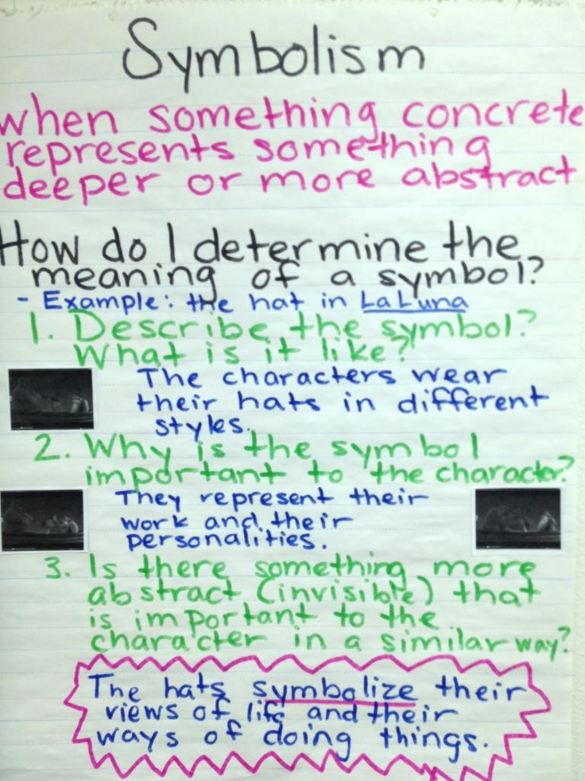](http://thatteachingblog.wordpress.com/2013/02/03/theme-and-symbolism/)**